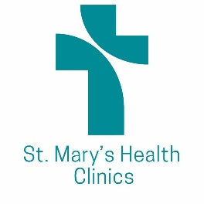
Nursing Supervisor

Temp to hire potential. 36 hours per week. Benefit eligible for medical, dental, life, long term disability, PTO, sick time, retirement, and free parking.
Please send resume or request for application to apply@csjstpaul.org

POSITION SUMMARY:

The Nursing Supervisor for St. Mary’s Health Clinics is responsible for general operations at their assigned clinic sites, including patient care coordination, general nursing and volunteer supervision, quality improvement activities, and maintenance of clinic supplies and other pertinent resources.

Assist leadership in establishing and implementing policies and processes to support efficient, safe, and quality care. Promote clinic activities and data monitoring to support quality improvement activities. Serve on project teams or committees as needed for development of clinic work.

QUALIFICATIONS / SKILLS / EXPERIENCE:

Basic education for registered nurse, BSN preferred. Work experience would be considered in lieu of a degree.

Licensure: Minnesota Registered Nurse License in good standing.
Valid driver’s license and reliable transportation to various clinic / outreach locations.

Minimum of three years’ work experience as an RN, preferably in an acute care setting with solid Medical Surgical background. Previous RN experience supervising unlicensed personnel.

Exceptional interpersonal skills, written and verbal, able to work with a variety of personalities, backgrounds and age groups. Ability to work independently and as a member of a team. Keen attention to detail, with timely follow up and response to patient needs.

Able to speak/write Spanish preferred.

Strong communication and interpersonal skills, able to function effectively as a team member, yet able to work independently. Proficiency in use of Microsoft office with strong data entry skills, alpha and numeric. Detail oriented, effective problem-solving skills.

Understanding of accounting principles related to billing and accounts payable.
Ability to work effectively with broad range of roles, professional staff, and clinical staff, other departments and systems, and patients and families served.

Understanding of privacy, confidentiality, and HIPAA regulations.

